Project Report Format

Project Title: Calculating Family Expenses Using Service Now
- INTRODUCTION
1.1 Project Overview
The project Calculating Family Expenses using ServiceNow is developed to provide a centralized platform for families to record, manage, and monitor their daily and monthly expenses. It includes features like expense entry, categorization, dashboards, and report generation for better financial tracking.

1.2 Purpose
The purpose of this project is to simplify expense management, ensure accurate financial calculations, and help families make informed budgeting decisions through secure and automated processes.

- IDEATION PHASE
2.1 Problem Statement
Many families find it difficult to track their daily and monthly expenses due to manual methods or unorganized records. This lack of proper tracking leads to poor budgeting and financial mismanagement. Therefore, a centralized and automated system is needed to efficiently manage and analyse family expenses.

2.2 Empathy Map Canvas

User
- Family members managing household expenses
- Working individuals tracking monthly spending
- Parents planning family budgets
Needs
- Easy expense entry and categorization
- Clear monthly summary and dashboard view
- Secure and reliable data storage
Pains
- Difficulty tracking daily expenses manually
- Overspending due to lack of monitoring
- Confusion from scattered financial records

Gains
- Better budgeting and expense control
- Clear financial insights through reports
- Improved financial planning and decision-making

2.3 Brainstorming
Based on the identified problem, the following ideas were considered during brainstorming:
- Identify common problems families face while tracking expenses.
- Generate ideas for features like expense entry, categorization, and dashboards.
- Discuss automation options for calculating totals and monthly summaries.
- Explore security features such as login authentication and role-based access.
- Evaluate ideas based on feasibility and user convenience before finalizing the solution.

- REQUIREMENT ANALYSIS

  - Customer Journey map

Awareness:
Users realize the need for a better and more organized way to track and manage their family expenses digitally.
Registration:
Users create an account easily to securely access and manage their expense tracking system.
Expense Entry:
Users quickly add daily income and expense details to maintain accurate financial records.

3.2 Solution Requirement
1. User Management:
The system should allow users to register, login, and securely manage their personal accounts.
2. Expense Tracking:
The application should enable users to add, edit, and delete daily income and expense records.
3. Reporting & Dashboard:
The system should generate visual reports and dashboards to analyze spending patterns.
4. Data Security & Validation:
The application should validate input data and ensure secure storage of financial information.

3.3 Data Flow Diagram
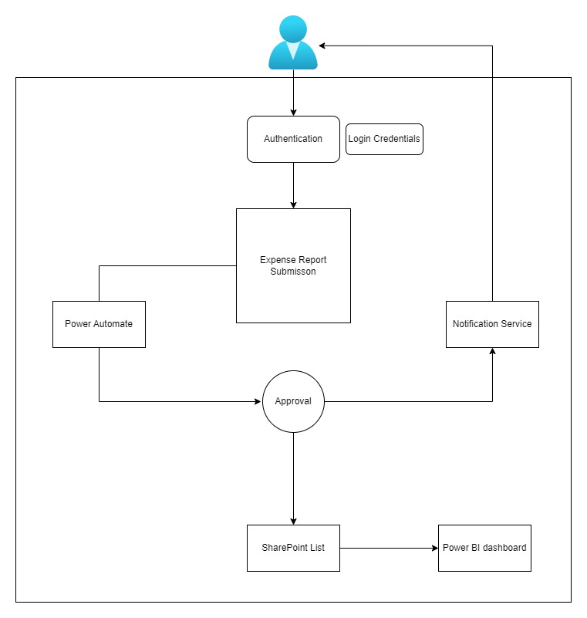

3.4 Technology Stack
- Platform: ServiceNow (Cloud-based PaaS).
- Database: Custom Tables (u_user, u_expense, u_income, u_category).
- Scripting: JavaScript (ClientScripts, Business Rules, Glide API).
- UI & Forms: ServiceNow Form Designer, UI Policies, and Process Flow Formatter.
- Reporting & Dashboard: ServiceNow Reports, Performance Analytics, and Interactive Dashboards
4. PROJECT DESIGN
4.1 Problem Solution Fit

1. Centralized Expense Management
Develop a cloud-based application to record, track, and manage family income and expenses in one unified dashboard.

2. Smart Monitoring & Insights
Provide real-time reports, category-wise analysis, and alerts to help users control spending and improve financial planning.

4.2 Proposed Solution

1. Secure User Management
Implement a secure login and role-based access system to ensure safe and personalized expense tracking.

2. Automated Expense Tracking System
Develop a centralized platform to record, categorize, and automatically calculate daily and monthly expenses.

3. Insightful Reporting & Budget Analysis
Provide interactive dashboards and reports to analyze spending patterns and support better financial decision-making.

4.3 Solution Architecture

1. Application & Business Logic Layer
Handles user registration, expense processing, validation, and automated calculations using ServiceNow workflows and scripts.

2. Data & Reporting Layer
Manages secure storage of expense records in custom tables and generates dashboards and reports for financial analysis.

5. PROJECT PLANNING & SCHEDULING
5.1 Project Planning
• Weeks 1–2: ServiceNow instance setup and creation of database architecture (u_user, u_expense, u_income, u_category tables).
• Weeks 3–4: UI configuration (Form Design, Service Portal setup) and implementation of Client Scripts, Business Rules, and Flow Designer for expense automation.
• Week 5: Functional testing, dashboard/report validation, bug fixing, and final project documentation preparation.

6. FUNCTIONAL AND PERFORMANCE TESTING
6.1 Performance Testing
Efficiency:
The system processes expense entries and generates reports quickly with minimal response time.
Accuracy:
The application ensures correct calculations of totals and category-wise expenses without data errors.
Security:
The system protects user financial data through authentication, role-based access control, and secure storage.

7. RESULTS
7.1 Output Screenshots
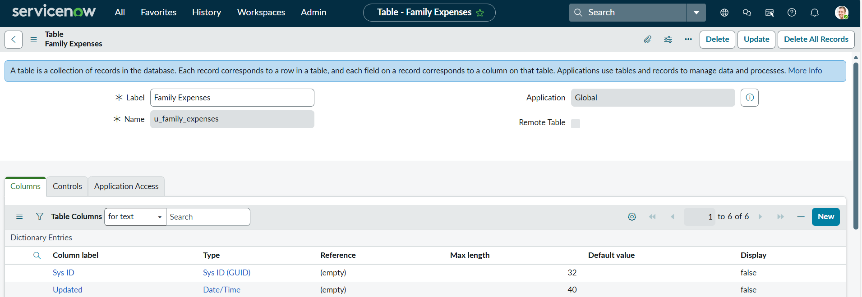

Fig: Table creation of Family Expenses
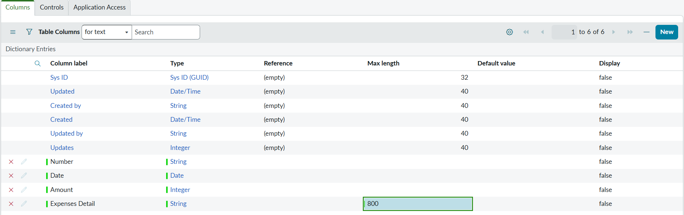
Fig: Creation of column fields to configure the form
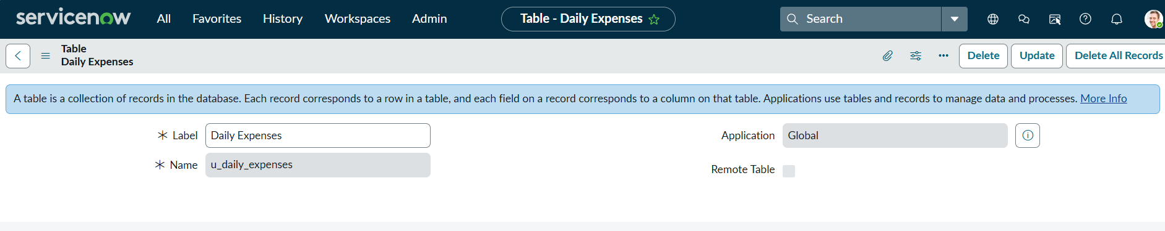
Fig: Table Creation of Daily Expenses

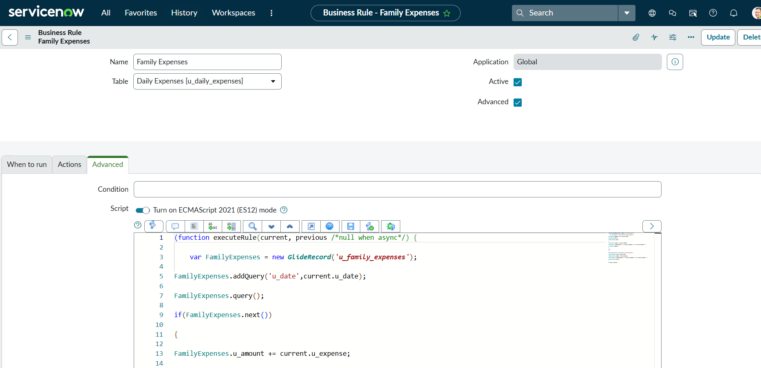
Fig: Creation of Business Rules

8. ADVANTAGES & DISADVANTAGES
Advantages:
The system provides centralized, secure, and automated expense tracking with clear financial insights for better budgeting.
Disadvantages:
The application depends on internet connectivity and requires basic technical knowledge to use effectively.

9. CONCLUSION
The Calculating Family Expenses using ServiceNow project provides a secure and efficient platform for managing household financial activities. By centralizing expense tracking, automating calculations, and offering visual dashboards, the system improves budgeting and financial awareness. Overall, it simplifies expense management and supports better financial decision-making for families.

10. FUTURE SCOPE
1. Mobile Application Integration
Develop a dedicated mobile app to allow users to track expenses anytime and receive real-time notifications.
2. AI-Based Spending Insights
Integrate predictive analytics to analyze spending patterns and suggest smart budgeting recommendations.
3. Multi-User & Family Sharing Feature
Enable multiple family members to access and manage shared expense data with controlled permissions

11. APPENDIX
Source Code (if any)

Below are the key Client Scripts used in the application:
    - Client Scripts of Business Rules
(function executeRule(current, previous /*null when async*/) {

var FamilyExpenses = new GlideRecord('u_family_expenses');
FamilyExpenses.addQuery('u_date',current.u_date);
FamilyExpenses.query();
if(FamilyExpenses.next())
{
FamilyExpenses.u_amount += current.u_expense;
FamilyExpenses.u_expense_details += ">"+current.u_comments+":"+"Rs."+current.u_expense+"/-";
FamilyExpenses.update();
}
else
{
var NewFamilyExpenses = new GlideRecord('u_family_expenses');
NewFamilyExpenses.u_date = current.u_date;
NewFamilyExpenses.u_amount = current.u_expense;
NewFamilyExpenses.u_expense_details += ">"+current.u_comments+":"+"Rs."+current.u_expense+"/-";
NewFamilyExpenses.insert();
}

})(current, previous);

- Total Update Client Scripts for Configure of relationships
(function refineQuery(current, parent) {

current.addQuery(field, value);
current.addQuery('u_date',parent.u_date);
current.query();

})(current, parent);

GitHub Link: PatnamNagaVishnavi/Calculating-Family-Expenses-Using-Service-Now

Project Demo Link:
https://drive.google.com/file/d/1u5oXyMSo_M1Ij2LpIsujgLq0CV27Uid5/view?usp=drive_link

